ADDITION OVER 100

KS1 – 2001 Paper

1.

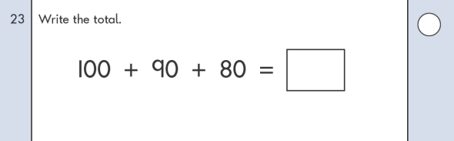

KS1 – 2003 Paper 2

2.

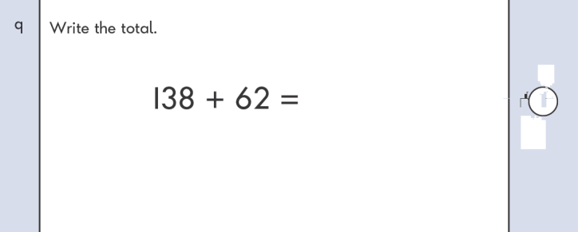

3.

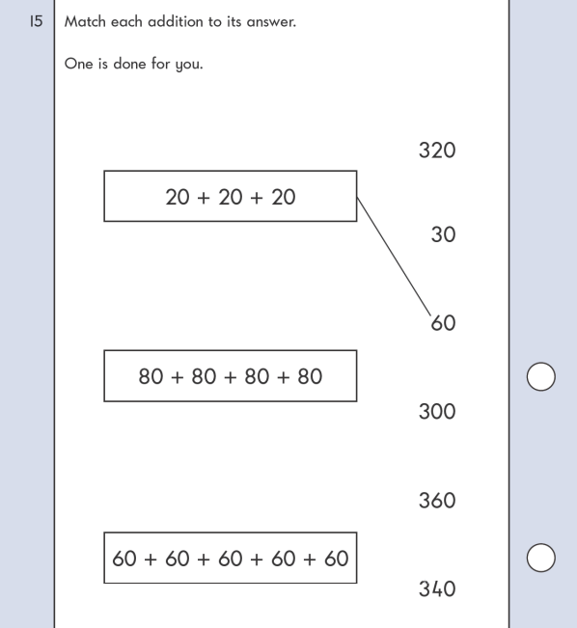

4.

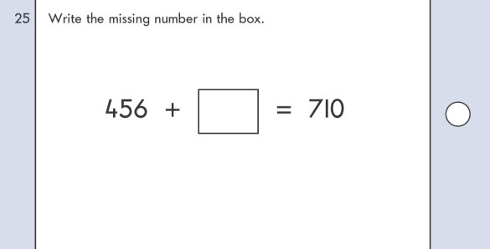

KS1 – 2004 Paper 2

5.

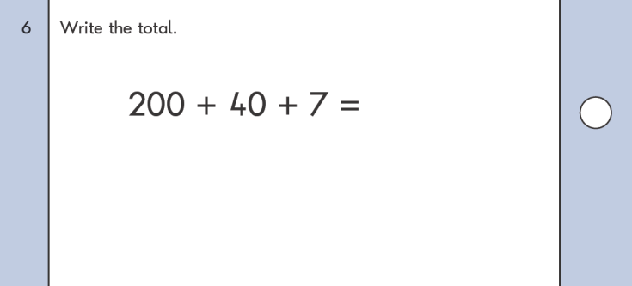

6.

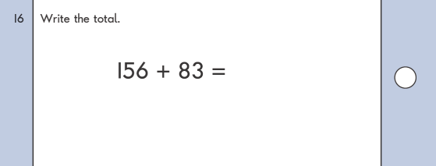

KS1 – 2005 Paper 1

7.

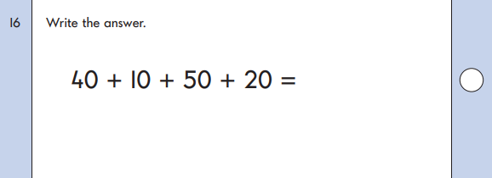

KS1 – 2005 Paper 2

8.

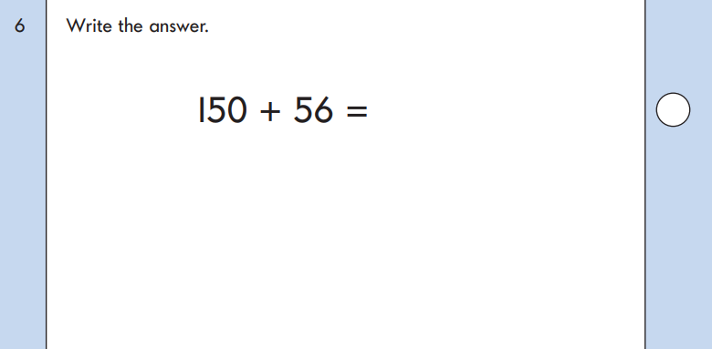

KS1 – 2007 Paper 2

9.

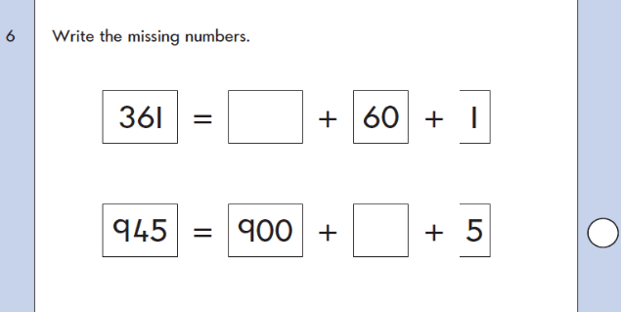

10.

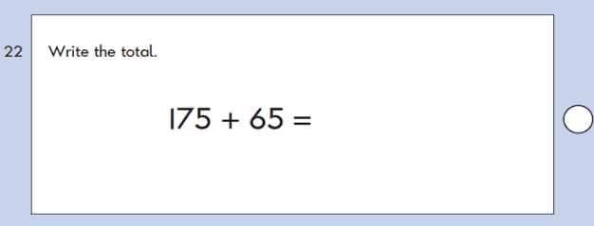

KS1 – 2018 Paper – Arithmetic

11.

